***NM SMARTINTERNZ PROJECT***

***NM SAMART INTENZ PROJECT***

***PROPERTY MANAGEMENT APPLICATION USING SALESFORCE***

***BY-BSC. PHYSICS AT GOVERNMENT ARTS COLLAGE,UDUMALPET***

***TEAM - DEEPAN.R, ABARNA.B, DHAYANA MOORTHI.K, BABU.G***…

INTRODUTION

***OVERVIEW:***

“Property management is the operation, control, maintenance, and oversight of real estate and physical property. This can include residential, commercial, and land real estate. Management indicates the need for real estate to be cared for and monitored, with accountability for and attention to its useful life and condition. This is much akin to the role of management in any business."

***PURPOSE***

* What is real time salesforce project,
* Object and relationships
* Profile
* User
* Reports
* Dashboards

***PROBLEM DEFINITION& DESIGNTHINGING***

* ***EMPATHY MAP***

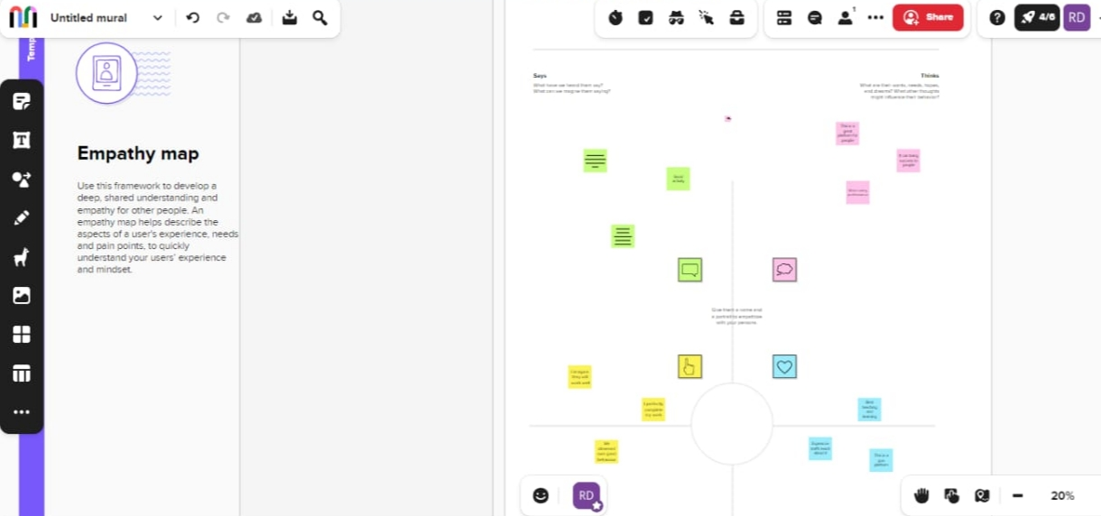

* ***BRAIN STORMING MAP***

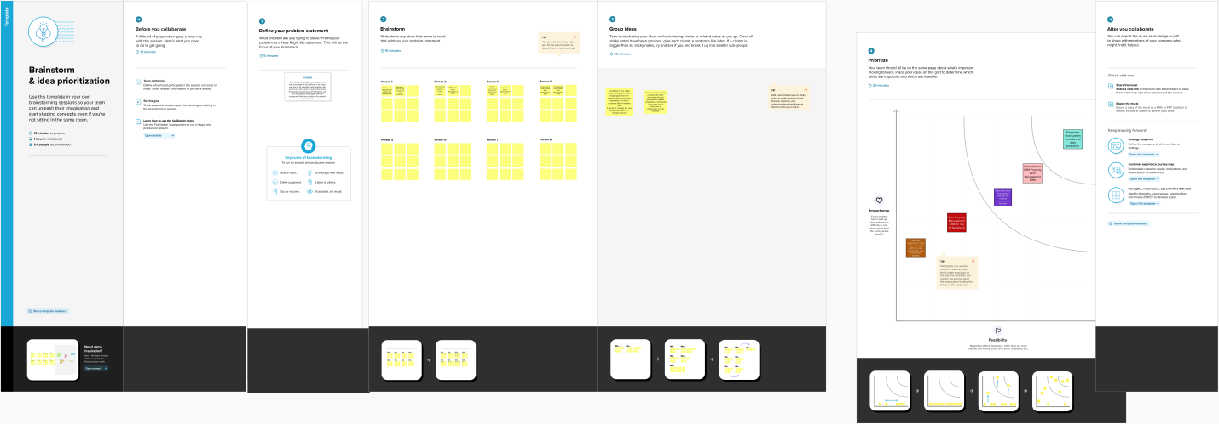

***RESULT DATA MODEL***

|  |  |  |  |  |  |
| --- | --- | --- | --- | --- | --- |
| **OBJECT NAME** | |  |  | | --- | --- | | **FIELDS IN THE OBJECT** |  | | **FIELD LABLE** | **DATA TYPE** | |
| **BUY** | **1.BUY PICKLIST** |

|  |  |  |  |  |  |
| --- | --- | --- | --- | --- | --- |
|  | |  |  | | --- | --- | | **2.DISCOUNT** | **PERCENTAGE** | | **3.STATE** | **PICKLIST** | |
|  | **4.CITY DEPENDENCY** |

|  |  |  |  |  |  |
| --- | --- | --- | --- | --- | --- |
| **RENT** | |  |  | | --- | --- | | **1.RENT** | **AUTO NUMBER** | | **2.RENTAL CITY** | **TEXT** | |
|  | **3.BHK TYPE PICKLIST** |

|  |  |  |  |  |  |
| --- | --- | --- | --- | --- | --- |
| **LOAN** | |  |  | | --- | --- | | **1.LOAN ID** | **AUTONUMBER** | | **2.INTEREST RATE** | **CURRENCY** | |
|  | |  |  | | --- | --- | | **3.TERM** | **NUMBER** | | |  | | --- | | **4.ANNUAL LOAN** | | |  | | --- | | **NUMBER** | | |

|  |  |  |  |  |  |
| --- | --- | --- | --- | --- | --- |
|  | |  |  | | --- | --- | | **5.TOTAL LOAN INSTALMENT** | **NUMBER** | | **6.LOAN REPAYMENT** | **NUMBER** | |
|  | **7.LOAN AMOUNT FORMULA** |

**ACTIVITY 1**

**BUY**

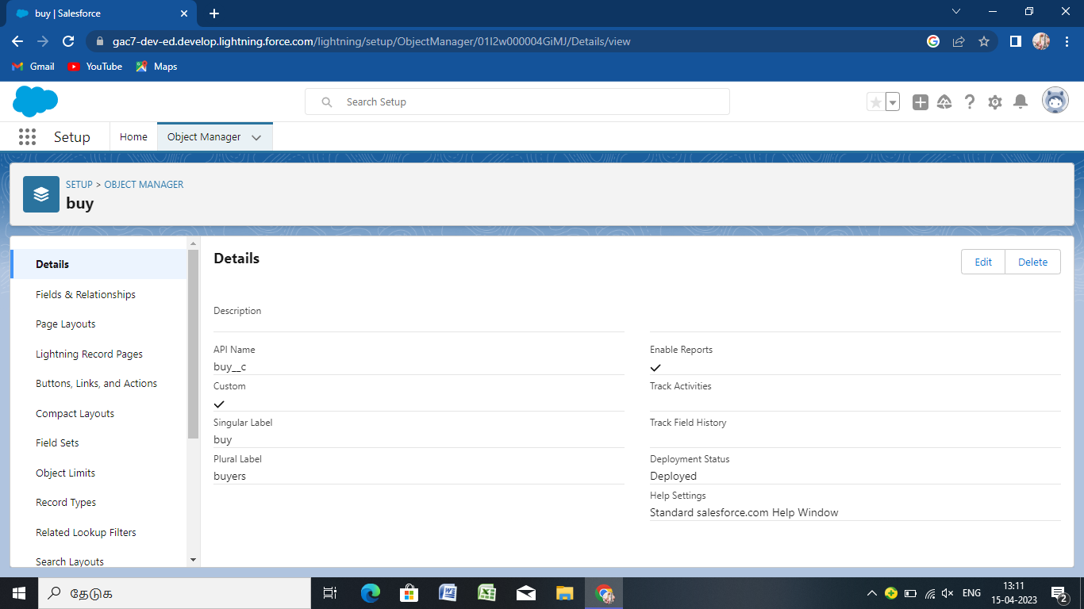

**ACTIVITY 2**

**RENT**

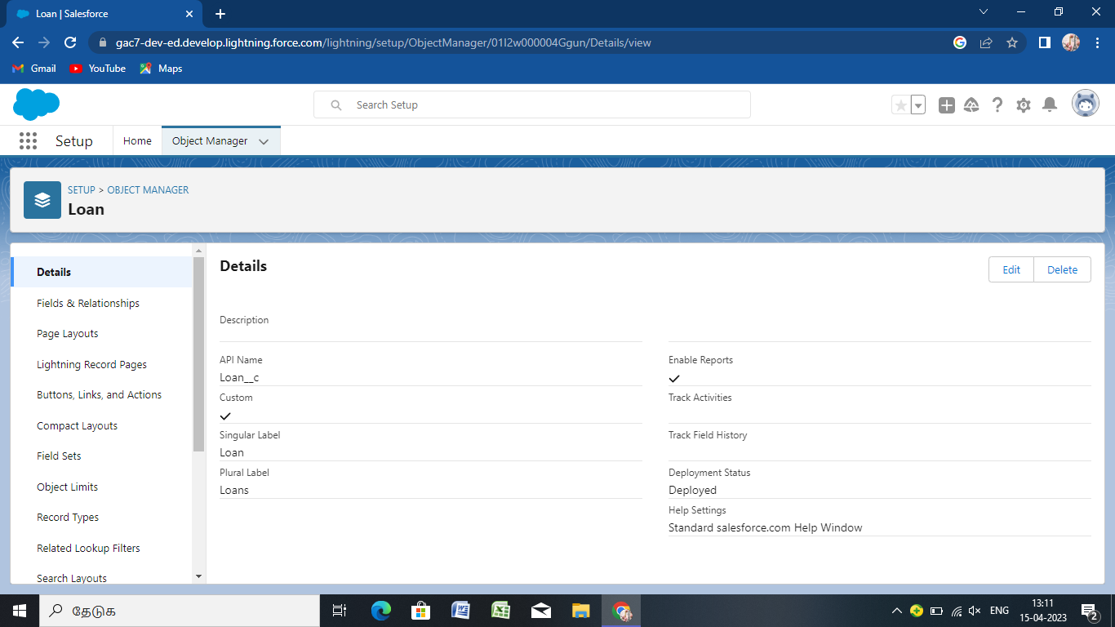

|  |
| --- |
|  |
|  |

**ACTIVITY 3**

**LOAN**

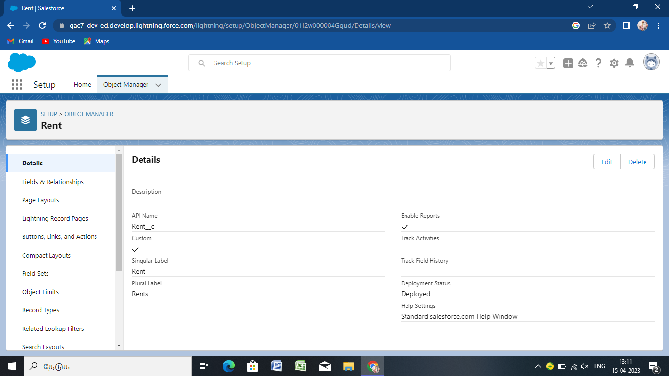

FIELDS AND RELATIONSHIP

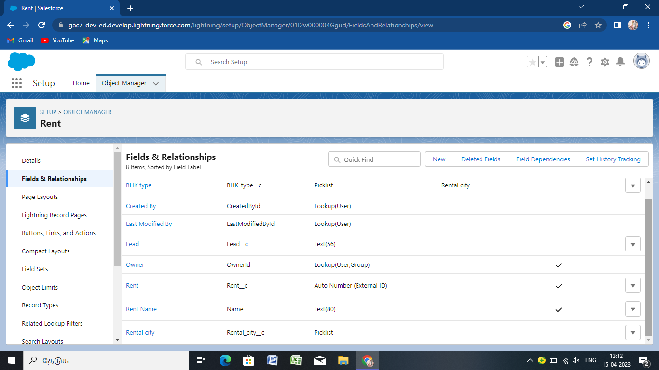

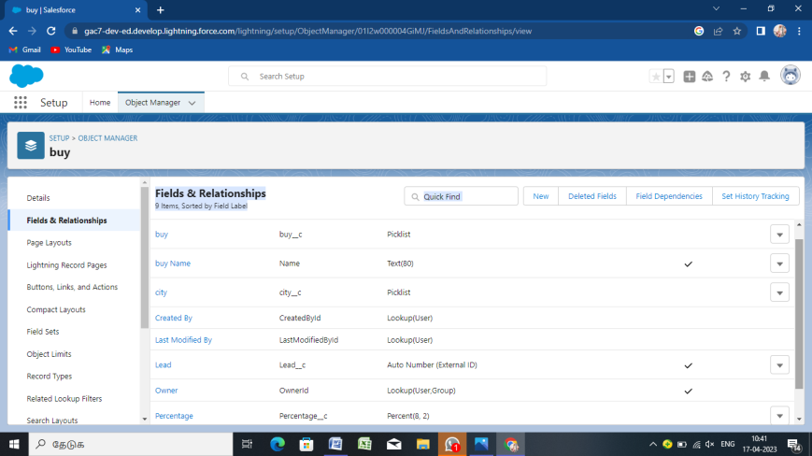 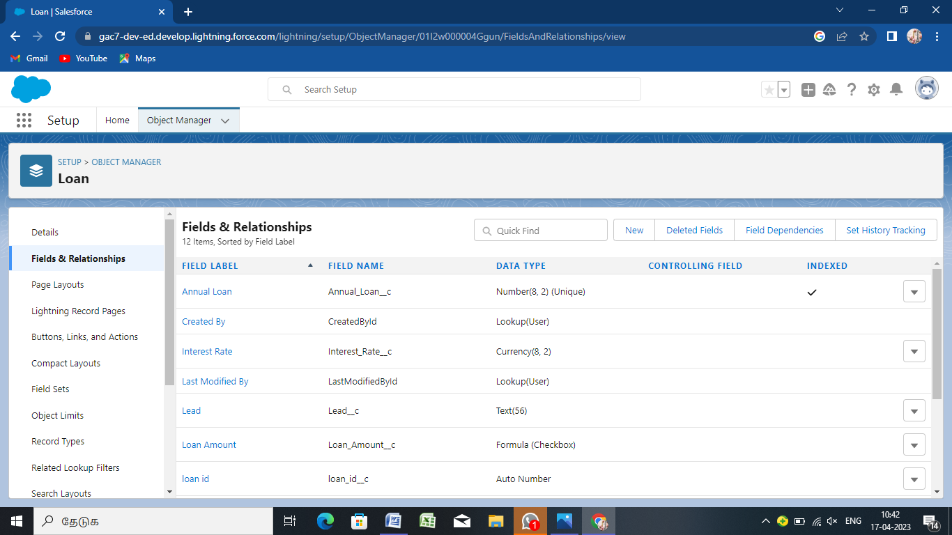

PROFILE:

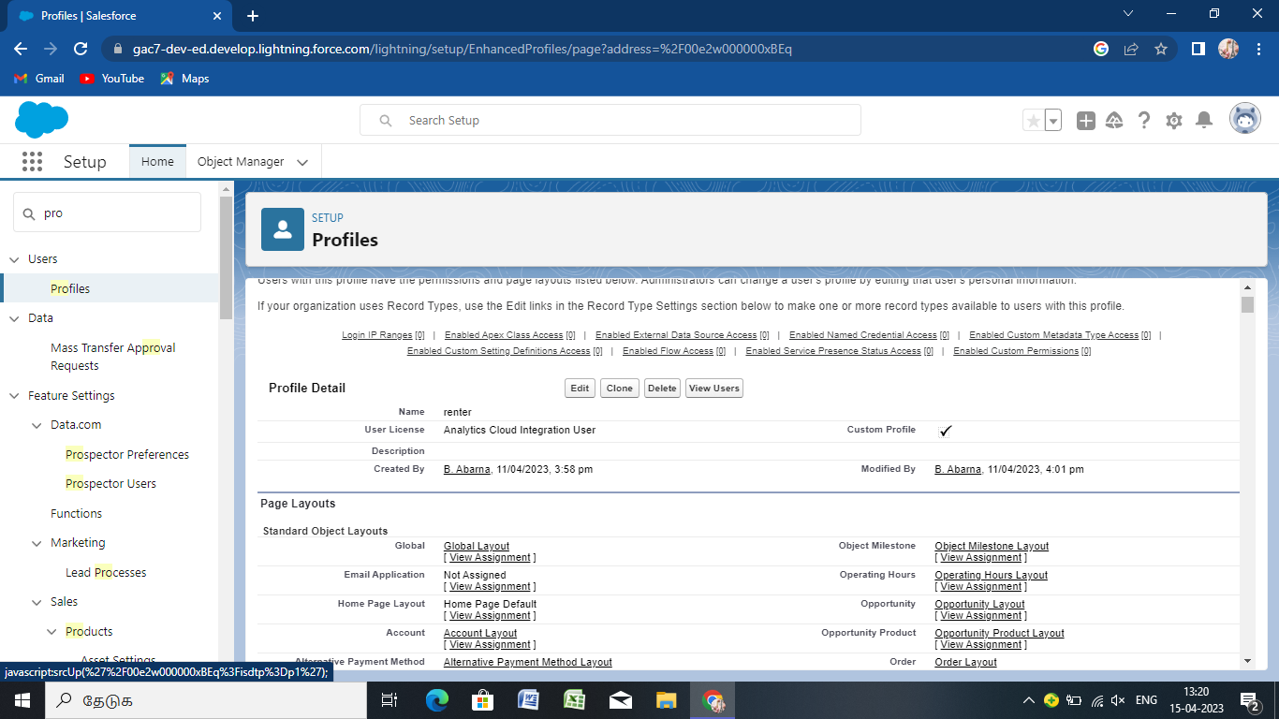

USER:

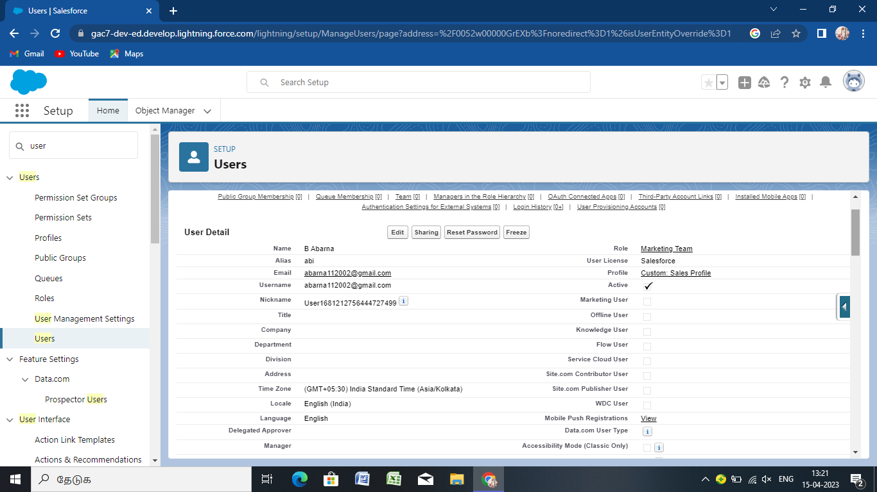

PERMISSION SET:

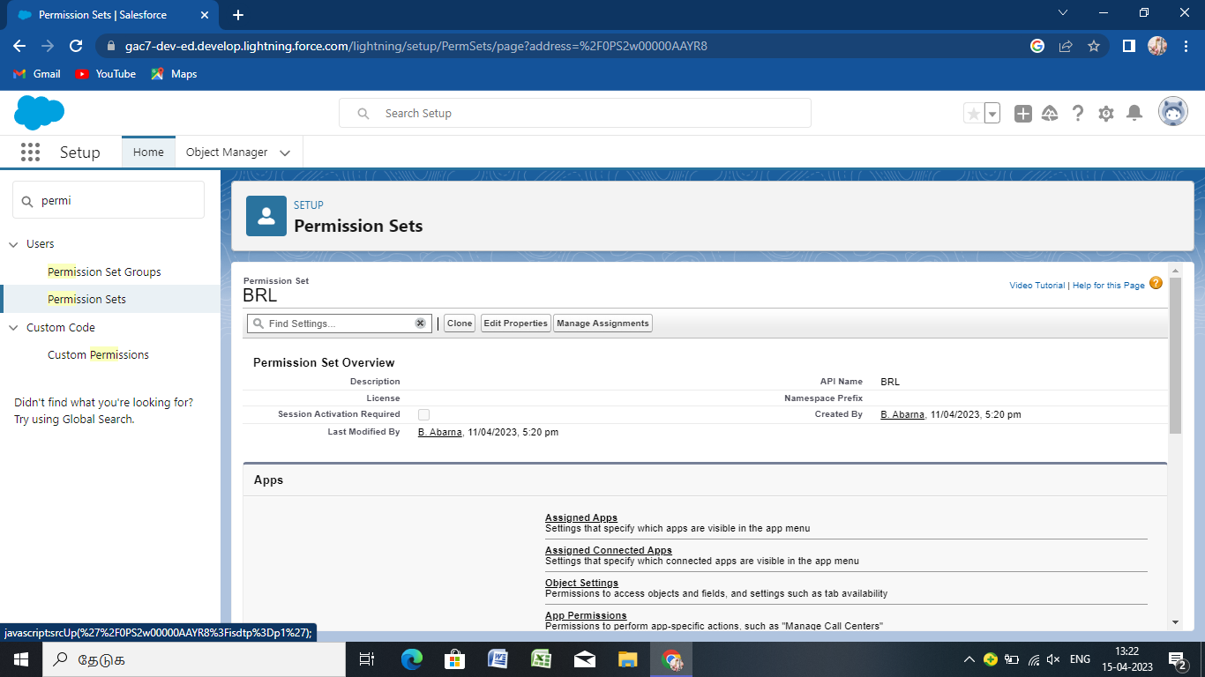

SETUP FOR OWD:

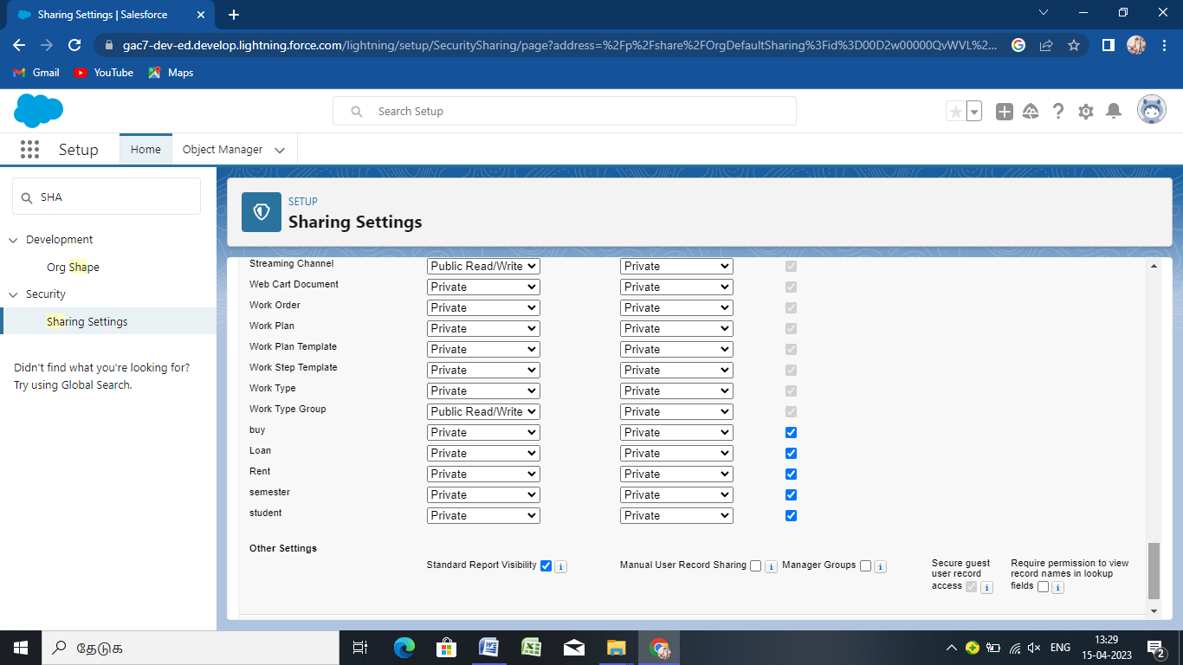

REPORT:

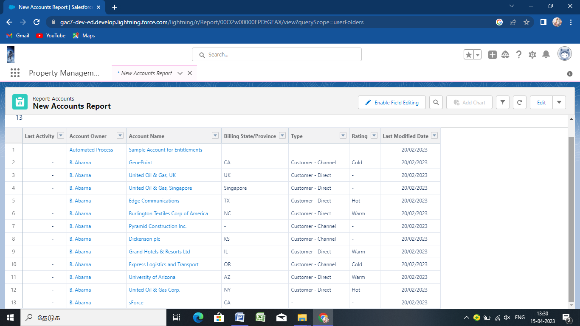

DASHBOARDS:

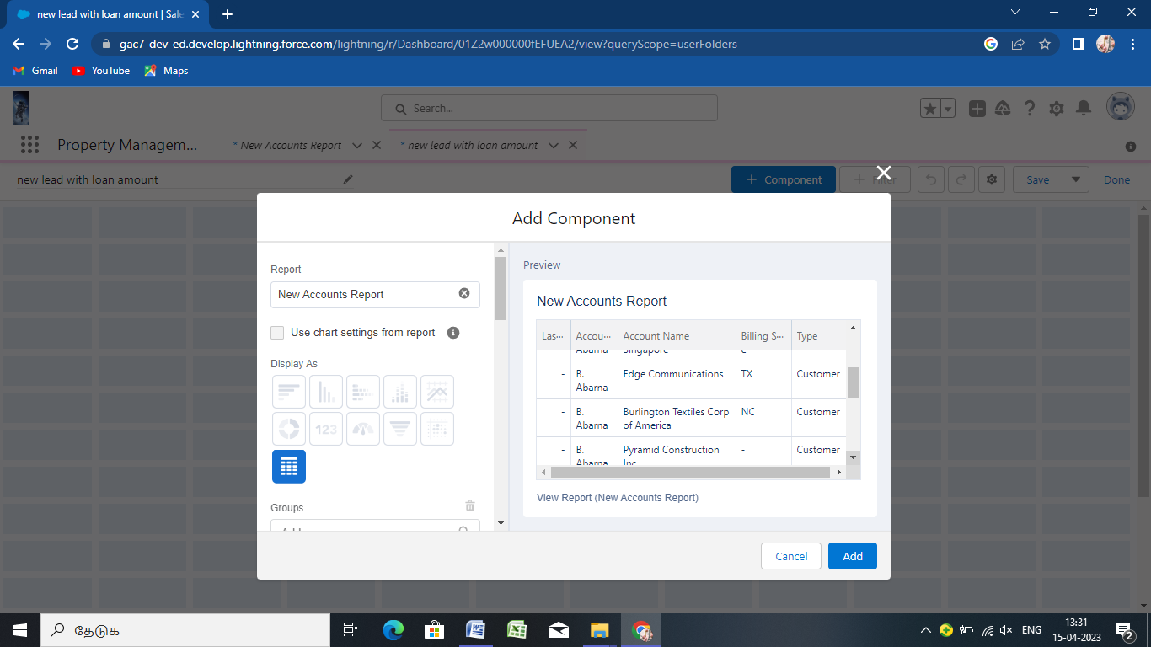

TRAILHEAD PROFILE PUBLIC URL:

TEAM LEAD

<https://trailblazer.me/id/deepr60>

team member one

<http://trailblazer.me/id/abarb292>

team member two

<https://trailblazer.me/id/dhphy>

team member three

https://trailblazer.me/id/babug8tps

ADVANTAGE & DISSADVANTAGE

ADVANTAGE

*Save time for value added work .

*flexbile system for both employer and the agence.

*easy job posting.

*improved cast-pre-higher.

*faster and better desison.

DISADVANTAGE

*A Disadvantage of ATS if missing qualified applicans you to wrong key word selection.

*automatic elimination of resume that software can not reganize and interpret is another drawback of

ATS.

*an applicant tracking system disadvantage is that they are open ti manipalation.

APPLICATION

*An applicant tracking system is a software application that enables the electronic handling of

recruitment and hiring needs.

CONCLUSION

Applicant tracking system for recruiter is a very effective hiring solution that most of the successful

recruiter utilize.becase without it,there is a good chance that your process of moving applicants through

different stages can become very difficult. this tool is very important for optimizing the hiring process

with the help of artificial intelligent and technology . As we move forward,the ATS tools are evolving and

making the monotonous tasks easy.

FUTURESCOPE

*Traditional applicant tracking system

*Modern applicant tracking system.

*ATS Will begin to look and act more like social network

*Appilicant tracking systems have become more user-friendly

*there is a rise in AI-based applicant tracking system.